Standard Operating Procedure

Chemical name and concentration: Dichloromethane, 75-09-2, ≤100%

This is an SOP template. It is not complete until:

- Lab specific information is entered into the box below.
- Lab specific protocol and procedure is added to the protocol and procedure section.
- SOP has been signed and dated by the PI and relevant lab personnel.
- All italicized/red text has been removed/replaced with information specific to the chemical.
Print a copy and insert into your Laboratory Safety Manual and Chemical Hygiene Plan. Refer to instructions for assistance.

School and department: | Click here to enter text.
SOP preparation date: | Click here to enter a date. | SOP approval date: | Click here to enter a date.
Principal investigator: | Click here to enter text.
Lab manager name: | Click here to enter text.
Laboratory phone: | Click here to enter text. | Office phone: | Click here to enter text.
Emergency contact: | Click here to enter text. | Contact phone: | Click here to enter text.
Laboratory locations covered by this SOP – building and room number
Click here to enter text.

Type of SOP | ☐ | Process | ☒ | Hazardous chemical | ☐ | Hazardous class

Hazards Identification

GHS Classification
Skin irritation (Category 2)
H315 Eye irritation (Category 2A)
H319 Carcinogenicity (Category 2)
H351 Specific target organ toxicity - single exposure (Category 3), Central nervous system, H336

GHS Label Information

Pictogram
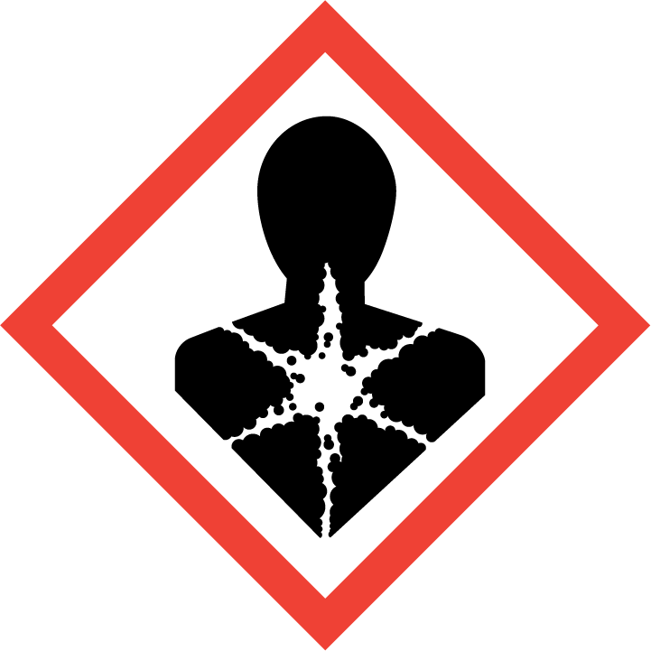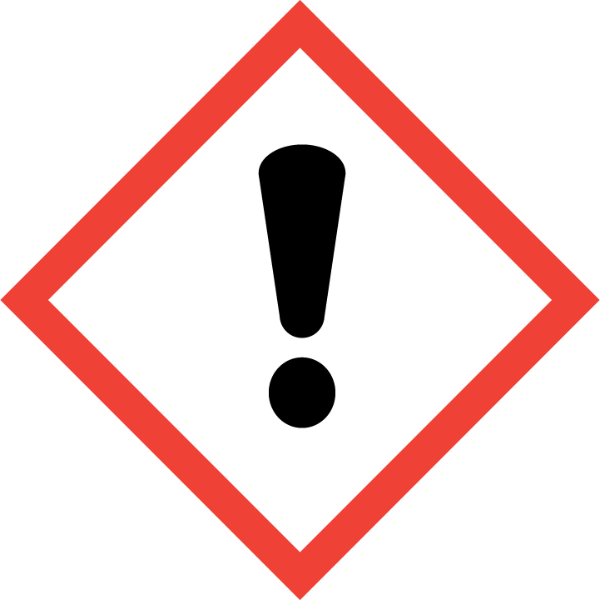

Signal Word
Warning

Hazard Statement(s)
H315 Causes skin irritation
H319 Causes serious eye irritation.
H336 May cause drowsiness or dizziness.
H351 Suspected of causing cancer.

Precautionary Statement(s)
P201 Obtain special instructions before use.
P202 Do not handle until all safety precautions have been read and understood. P261 Avoid breathing dust/ fume/ gas/ mist/ vapours/ spray.
P264 Wash skin thoroughly after handling.
P271 Use only outdoors or in a well-ventilated area.
P280 Wear protective gloves/ protective clothing/ eye protection/ face protection.
P302 + P352 IF ON SKIN: Wash with plenty of soap and water. P304 + P340 + P312 IF INHALED: Remove person to fresh air and keep comfortable for breathing. Call a POISON CENTER/doctor if you feel unwell.
P305 + P351 + P338 IF IN EYES: Rinse cautiously with water for several minutes. Remove contact lenses, if present and easy to do. Continue rinsing.
P308 + P313 IF exposed or concerned: Get medical advice/ attention.
P332 + P313 If skin irritation occurs: Get medical advice/ attention.
P337 + P313 If eye irritation persists: Get medical advice/ attention.
P362 Take off contaminated clothing and wash before reuse. P403 + P233 Store in a well-ventilated place. Keep container tightly closed.
P405 Store locked up.
P501 Dispose of contents/ container to an approved waste disposal plant.

Physical and Chemical Properties

CAS | 75-09-2 | Melting Point/Range | -97 °C (-143 °F)
Molecular Formula | CH₂Cl₂ | Boiling Point/Range | 39.8 - 40 °C  103.6 - 104 °F
Molecular Weight | 84.93 g/mol | Flash Point | Does not flash
Physical State, Color | Liquid, clear, colorless | Upper flammability/ explosion limit | 22% (V)
Odor | Ether-like | Lower flammability/ explosion limit | 13% (V)
Odor Threshold | 250 ppm | Autoignition Temp. | 605 °C (1121 °F) at 1,013 hPa  - DIN 51794
Evaporation Rate | 27.5 (butyl acetate = 1) | Decomposition Temp | No data available

First Aid Procedures

If inhaled, move to fresh air. If the person is not breathing, give artificial respiration. Avoid mouth to mouth contact. Call 911. Then call EHS at 480-965-1823.

In case of skin contact, immediately remove all contaminated clothing and flush affected area for 15 minutes. Call 911. Then call EHS at 480-965-1823.

In case of eye contact, use nearest emergency eyewash immediately. Remove any contact lenses. Call 911. Then call EHS at 480-965-1823.

If swallowed, do not induce vomiting. Never give anything by mouth to an unconscious person. Call 911. Then call EHS at 480-965-1823.

Spill and Accident Procedure

Personal precautions
- Avoid breathing vapors, mist or dust.
- If the spill happened outside of a fume hood, evacuate the lab and call EHS (480-965-1823).
- Do not attempt clean-up without the required PPE (see below).

Environmental precautions
Prevent further leakage or spillage – if safe to do so. Do not allow product to enter drains.

Methods and materials for containment and clean-up
- Consider material compatibility prior to clean-up. Verify the spill is not releasing hazardous fumes outside of a fume hood. Verify spill kit is available. Verify correct PPE is being worn.
- Immediately assess amount spilled, follow posted ASU Emergency Response Guide procedures for hazardous materials incidents.
- If a chemical exposure has occurred, follow First Aid Procedures above. A fellow lab worker shall call 9-1-1 and seek immediate medical attention. Then call EHS at (480) 965-1823.
- Secure / restrict access to the area of the spill to prevent spread of the chemical.
- Use the available spill kit to stop and contain the spill. Bag the collected material.
- Label and tag as hazardous waste and submit a pick-up request to EH&S using EHS Assistant. https://ehsaweb.asu.edu/

Personal protective equipment (PPE) & Engineering Controls

Respiratory Protection
Use only inside a properly-functioning certified fume hood. Do not allow any open containers outside the fume hood.

Hand Protection
Polyvinyl alcohol (PVA) gloves are required.

Dichloromethane readily passes through nitrile, neoprene/chloroprene, and viton/butyl rubber gloves. It also passes through laminate film gloves in as little as 20 minutes. Only use the approved PVA gloves for handling dichloromethane.

For handling techniques where thick PVA gloves prevent the completion of the task, such as syringe or pipette use, consult the Working with Thick Gloves guide.

Use proper glove removal technique to avoid skin contact with this product.

Eye protection
- Wear chemical splash goggles to protect from splash hazards and chemical vapors.
  - Chemical splash goggles must meet ANSI Z87.1 D3 certification. Goggles must be properly-fitted to the face to provide an adequate seal against splashes.
- Goggles must be worn at all times by all lab personnel within splash range of the work performed if the work involves any liquids that are not plain water.

Skin and body protection
- Lab coat
- Full-length pants
- Fully-enclosed rubber or leather shoes

Hygiene measures
Avoid contact with skin, eyes, and clothing. Wash hands before breaks and immediately after handling the product.

Storage

- Ensure the container is tightly closed at all times with a lid that will not come loose in the event that the container tips over (parafilm is not a substitute).
- Store in a dry & well-ventilated place.
- Dichloromethane is subject to slow hydrolysis which is accelerated by light.
- Heat-sensitive; keep away from heat.
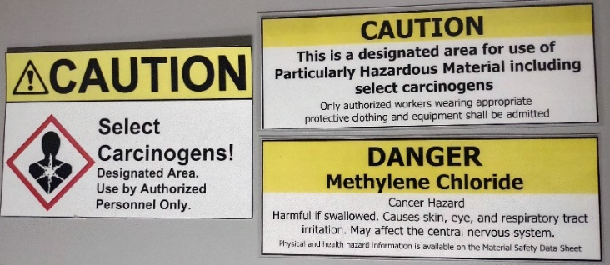
- Storage class (TRGS 510): 6.1D: Non-combustible, acute toxic Cat.3 / toxic hazardous materials or hazardous materials causing chronic effects
- Store separately from the following incompatible materials:
  - Strong oxidizers (i.e. nitric acid)
  - Alkali metals
  - Powdered aluminum or magnesium
  - Strong bases (i.e. potassium tert-butoxide)
  - Strong caustics
  - Amines
  - Nitrogen tetroxide
  - Titanium
  - Zinc
  - Will attack some plastics, rubber, and coatings
  - On contact with water, will corrode iron, some stainless steels, copper, and nickel
- As an OSHA-listed carcinogen, the usage & storage area (either the fume hood & cabinet where it is used & stored, or the entire lab) must be designated as a carcinogen use area with warning signage.

Handling Requirements

- The lab where the material is being handled must have an approved / certified emergency eyewash and safety shower.
- Avoid contact with skin and eyes. Ensure you are wearing the required PPE and using appropriate engineering controls as stated below, including the required Polyvinyl Alcohol (PVA) gloves.
- For lab techniques where PVA gloves prevent necessary hand movements, consult the Working with Thick Gloves guide.
- Avoid inhalation of vapor or mist. Containers with this reagent may not be open unless they are inside a properly-functioning fume hood.
- Lab emergency contact information must be readily posted. Easy access to a cellular phone or land line is readily available.

Protocol and procedure

Laboratory-specific procedures
Add your lab’s specific procedures in this section. Write out separate steps in a list format for easy reading. Please include photos whenever possible. Be descriptive – future generations of researchers in your lab may need to learn the procedure from this document.
Click here to enter text.

Important note: Any deviation from this SOP requires advance PI approval.

Cleanup and Waste Disposal Procedure

Label waste
- Attach a completed ASU Hazardous Waste tag to all waste containers as soon as the first drop of waste is added to the container.

Store waste
- Store hazardous waste in closed containers, in secondary containment and in a designated location.
  - Do not store waste inside a fume hood. Clutter inside a fume hood will block the air flow and prevent the fume hood from working properly.
- Separate waste from any incompatible materials.
- Double-bag dry waste (kimwipes, gloves, etc.) using sealable transparent bags.
- Any waste objects that can penetrate bags (pipettes, swabs, razor blades, or syringes) must be placed inside a leak-proof container made out of a material that will resist cuts or punctures from those objects.
- The waste container must be brought inside the fume hood whenever waste is being added to it.
- Waste must be under the control of the person generating and disposing of it.

Dispose of waste
- Dispose of regularly generated chemical waste within 90 days or less (even if the container is not full).
- Use EHS Assistant online hazardous waste pick-up request system: https://ehsaweb.asu.edu/
- Contact ASU EH&S at (480) 965-1823 with questions.

Documentation of training

- Prior to conducting any work with this material, Principal Investigator or designee must provide to his or her laboratory personnel specific to the hazards involved in working with this substance, work area decontamination, and emergency procedures.
- The Principal Investigator must provide his/her laboratory personnel with a copy of this SOP and a copy of the Safety Data Sheet or SDS provided by the manufacturer.
- The Principal Investigator must ensure that his/her laboratory personnel have attended appropriate/required laboratory safety training or refresher training within the last one year.

I have read and understand the content of this SOP.
Employee name | ASU affiliate no. | Signature | Date

