Working with Thick Gloves
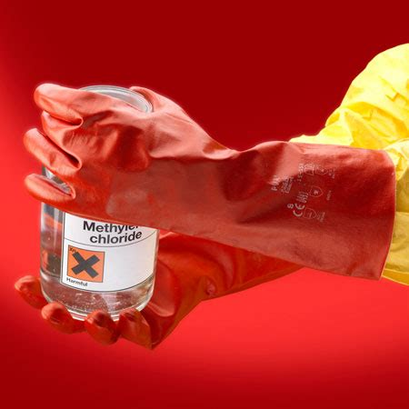
Because disposable nitrile gloves are easily permeated or degraded by certain common research chemicals, there are a variety of glove types available from various sellers. The glove compatibility or chemical resistance charts from these sellers will tell you what chemicals their gloves can handle.
Look closely at the specific glove noted on the chart, and look up the technical specifications of that particular glove. A nitrile glove on the compatibility chart may be a heavy-duty nitrile glove that is 11 mil or more thick, as opposed to the standard 3-5 mil thick disposable gloves – so even when a “nitrile” glove is compatible with a given chemical, you can only rely on nitrile that is as thick or thicker than the type listed on the chart. Take note of the breakthrough times too – you may need to change gloves mid-process to prevent breakthrough.
https://cdn.mscdirect.com/global/media/pdf/search/ansell/ansell-chemical-glove-resistance-guide.pdf
Most of these gloves are large and inhibit manual dexterity. With patience and practice, a person can achieve a level of manual dexterity similar to that of a person working with a glove box, but fine tasks like pipetting and syringe use are difficult. For handling situations where thick gloves are impractical, administrative safety techniques – mainly keeping the hands out of the potential path of the hazardous liquid – are outlined in the next section.
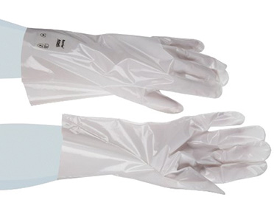
Laminate film gloves are unique among the heavy-duty glove types. These gloves are inelastic, flat, and don’t contour around the fingers in three dimensions the same way that other gloves do, resulting in flaps of flat material surrounding the fingertips. They also have a smooth outer texture that doesn’t easily grip onto glassware. You can mitigate this by pulling a disposable nitrile glove over the outside, to add a gripping surface and to cause the material to wrap around the fingertips.
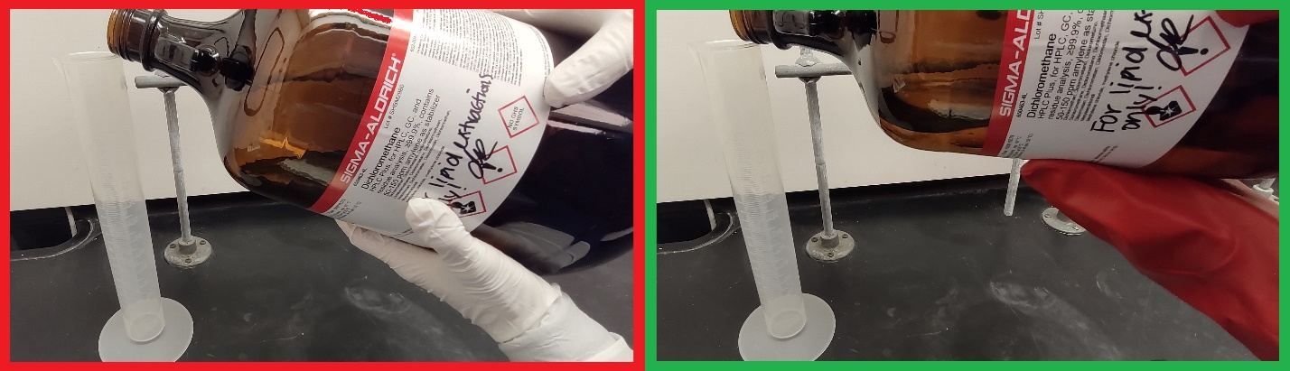
Impermeable gloves must be worn whenever large amounts of hazardous liquids are being handled, such as 20L solvent containers being used to fill 4L bottles. Impermeable gloves must also be worn whenever hazardous liquids are being poured out of a bottle.
Right image: Impermeable gloves (correct).
Left image: Permeable, disposable nitrile gloves (incorrect).
For filling containers with smaller amounts, the hazardous liquid can be poured while wearing impermeable gloves. A transfer pipette or syringe can also be used.
Right image: Hands with permeable gloves are kept out of liquid path (correct).
Left image: Permeable gloves with hand in path of liquid (incorrect).
Middle image: Impermeable gloves (correct).
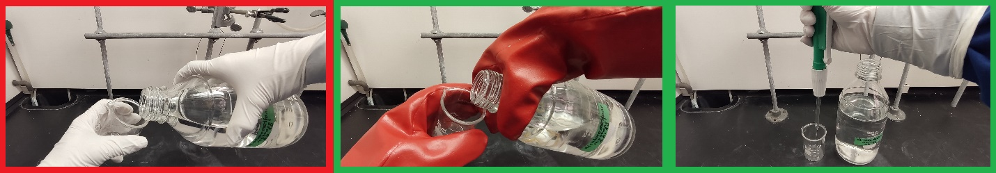
When wearing thick gloves, handling small amounts of liquid by pipette or syringe can be difficult. When permeable (disposable nitrile) gloves are the only hand protection, handling techniques must be adapted so that the hands never travel near the path of the liquid.
If you are wearing permeable gloves, never hold onto a test tube, NMR tube, or other container while a hazardous liquid is being poured into it. Always stabilize the container with a rack or clamp and keep your hands away.
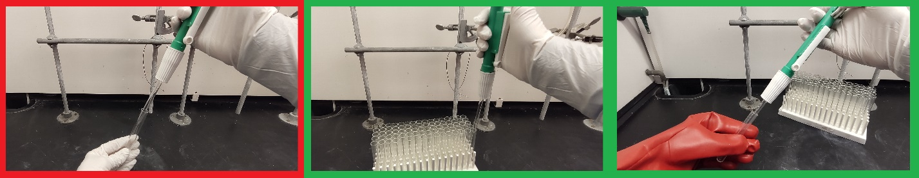
Middle image: Hands with permeable gloves are kept out of liquid path (correct).

Right image: Hand in liquid path is protected by impermeable glove (correct).
Left image: Permeable-gloved hand in path of liquid (incorrect).

For cleaning with hazardous liquids, the pieces being cleaned can be gently rinsed by pipette flow or by immersion in the liquid. Pieces must be manipulated with tongs or while wearing impermeable gloves.
The use of squeeze bottles with hazardous liquids is strongly discouraged due to the increased chance of splash/splatter with a hazardous liquid. If squeeze bottles are deemed necessary, the use of a sleeved apron (and a face shield, if the fume hood sash is not kept at or below chest height) is strongly recommended.
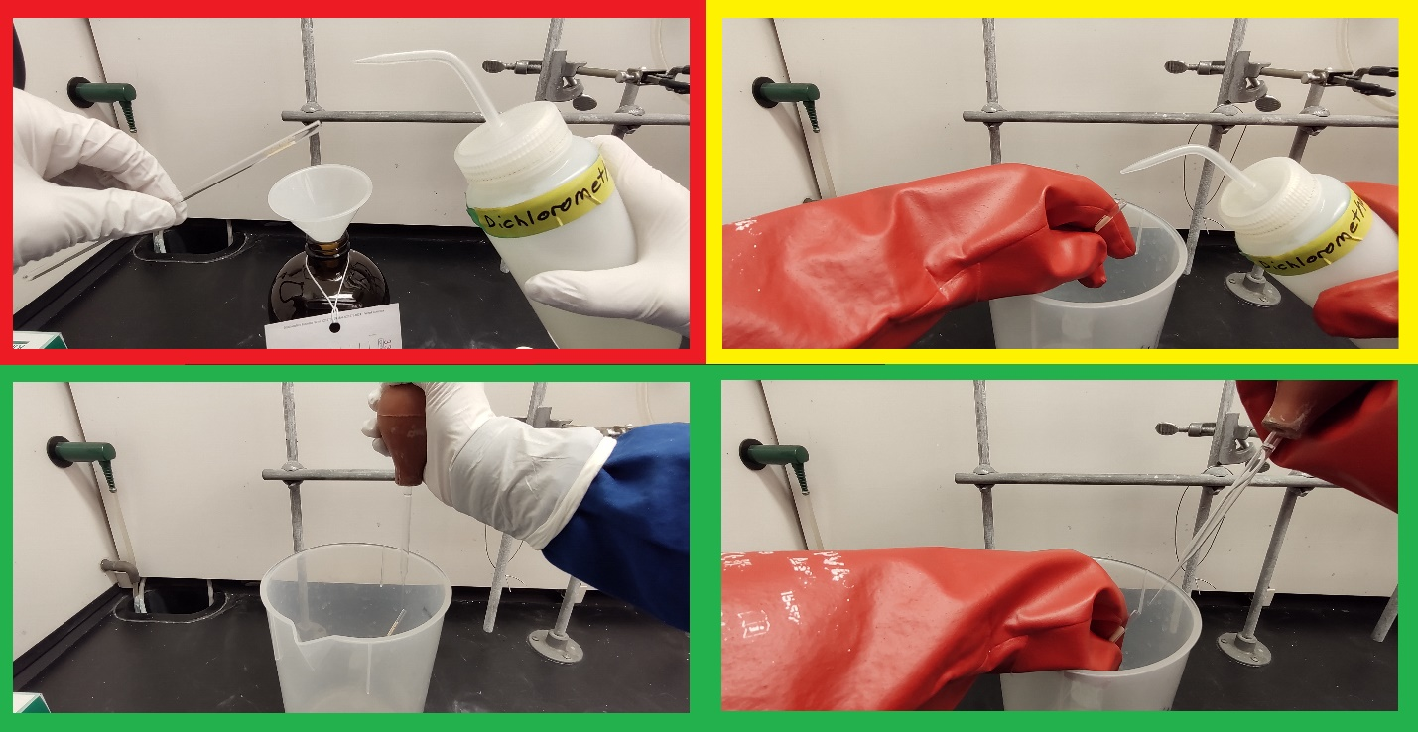
Upper-right image: Impermeable gloves and wash bottle (full-sleeved apron and face shield recommended).
Upper-left image: Permeable gloves and wash bottle (incorrect).
Lower-left image: Hands out of liquid path, no wash bottle (correct).
Lower-right image: Impermeable gloves, no wash bottle (correct).

Please reach out to FSE Safety with questions, suggestions, or to request special accommodation.

